Get the value and simplicity of Microsoft Office 365, a set of web-enabled tools that let you access your email, documents, contacts and calendars from virtually anywhere, on almost any device. The service brings together online versions of the best communications and collaboration tools from Microsoft.

Microsoft® Office 365 Features and Benefits

Work from Virtually Anywhere
Be productive on the go.
Rich client access via Office applications on PCs and Macs.
View and edit documents with Office Web Apps* across a broad range of browsers (Internet Explorer, Firefox, Safari).
Access your email from most browsers with Outlook Web App.
Access mail, contacts, calendar, and SharePoint® sites from mobile devices including Windows® Phones, Nokia, Android, iPhone and BlackBerry.
Look Professional
- Be what's next.
- Interface with customers using professional communications and collaboration tools.
- Deliver professional-looking documents to customers.
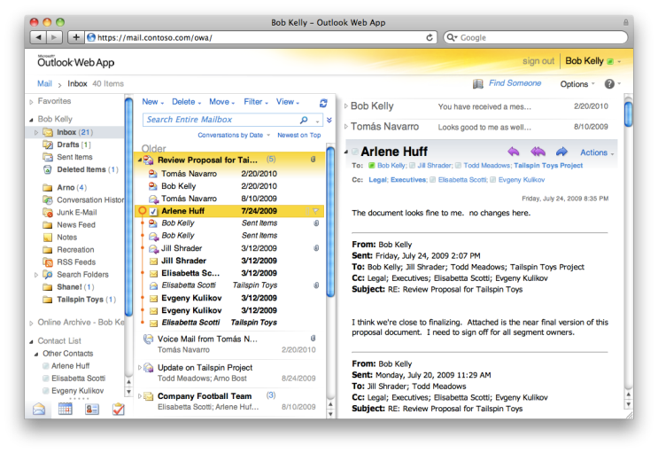
Web applications with cross-browser support
Collaborate Better
Work together, smarter.
Conduct online meetings with colleagues, partners and customers, including audio, video and screen sharing.
*If applicable.

Store your important Office documents and work together with colleagues, partners, and customers.
Share your calendar with colleagues, partners, and customers.

Share important business information, including Access databases.
Simultaneously edit documents with your colleagues.

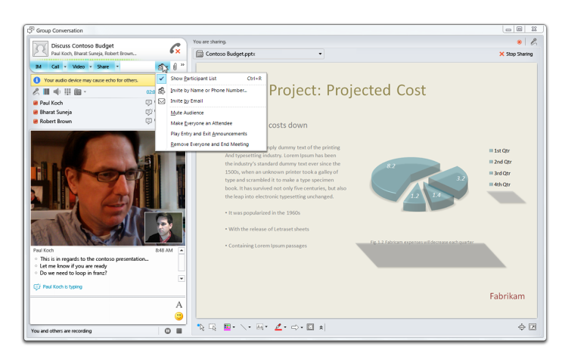
Online meeting presentation with PC-to-PC audio and video
Work with What You Know
Use familiar Office tools.
Work seamlessly with the programs you know and use including Microsoft Outlook®, Word, Excel®, and PowerPoint®.
Outlook powered by Exchange Online provides powerful tools for managing your email, calendar and contacts.
A familiar ribbon interface across the Office suite, including Web Apps.


Let us know what you think
http://www.facebook.com/office365

http://twitter.com/office365

